October 4th, 2018

Dear Editors,

We are pleased to submit our manuscripts “Performance of length-based data-limited methods in a multi-fleet context: application to small tunas, mackerels and bonitos in the Atlantic Ocean” and “Performance of catch-based and length-based methods in data-limited fisheries” for consideration for publication in ICES Journal of Marine Science.

In the first manuscript we estimated for the first time the current stock status of 10 different small scombrids stocks in the Atlantic Ocean using only life history information and length data. We highlighted stocks in need of management actions since they show signs of overfishing. We identified gaps in biological and fisheries information needed to better understand the status of these populations. A problem is that most of these species are caught by multiple fishing gears, and we propose a robust way to weigh the length composition data in multi-fleet situations when conducting length-based assessments.

In the second manuscript we evaluate a set of data limited assessments in which only one type of information is available (catch or length data), and we evaluate their performance under different scenarios of exploitation for species with contrasting life histories. We found that, due to differences in model structures and assumptions, all the methods performed differently in each scenario. Which model should be used to assess data-limited fisheries depends not only in the type of data available (catch or length), but in the prior knowledge about the exploitation history of the stocks and the biology of each species. We demonstrate that, for fisheries that are still developing, and time series of catch are not available, obtaining length-composition data could give a good approximation of the exploitation status of the stocks. In many of the scenarios tested, length-based models performed as well as catch-based models.

Our results will be of great interest to fisheries scientists, resource managers, and marine ecologists working in small scale fisheries where resources and data are limited. These manuscripts are an important contribution to the field by providing i) the first assessment for many small tuna stocks in the Atlantic Ocean, ii) a robust approach of how to combine length data from multi-fleet fisheries with different selectivity patters, and iii) the first comparison between length-based and catch-based data limited assessments.

None of the material submitted has been published or is under consideration elsewhere. All authors agree to be listed and have seen and approved the manuscripts, its content, and its submission to ICES Journal of Marine Science.

Thank you for considering these manuscripts. We look forward to hearing back from you.

Sincerely,

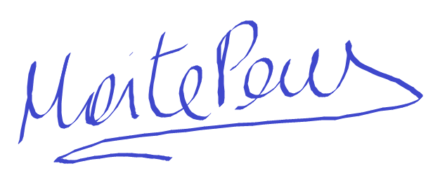

Maite Pons, PhD.
University of Washington, School of Aquatic and Fishery Sciences,
Box 355020, University of Washington, Seattle, WA 98195-5020, USA.
Phone: +1 (206) 883-5102
Email: mpons@uw.edu

